Modern Application Develeopment 1 Project Report

1. Student Details
Name: | Adithya Sabarish Saravanan
Roll Number: | 22f3000018
Email: | 22f3000018@ds.study.iitm.ac.in
About Me: | I am online degree student pursuing the BS in data science degree from Germany. I have completed my master’s degree with AI specialization in Germany and due to my interest in Mathematics, I am pursuing my career and working now as Cryptographic Algorithm developer at Infineon Technologies.

2. Project Details

Project Title: Hospital Management System

Problem Statement:
To build a Hospital Management System (HMS) web application that allows Admins, Doctors, Patients to interact with the system based on their roles.

Approach:
The app was built using Flask, SQLALCHEMY and other Jinja libraries as the backend framework with a modular structure. It allows patients and doctors to effectively interact and rendering functionalities to the user based on their needs. The final visual features are handled by HTML template rendering.

3. AI/LLM Declaration
I used GitHub Co-pilot:
- Only to improve the python classes (database relations). Like for example, while defing the backref relationships between relations.
- HTML templates: To improve the manifestations of Buttons, and for CSS based table formatting.
- The extent of AI/LLM usage is around 10–12%, limited to code suggestions and style formatting.
All final implementation logic, debugging, and integration were done manually.

4. Technologies and Frameworks Used
Technology / Library | Purpose
Flask | Core backend web framework
SQLAlchemy | Object Relational Mapper for SQLite database
Jinja2 | Template engine for rendering dynamic HTML pages
Bootstrap 5 | Frontend styling and responsive design
Chart.js | To visualize trends such as activity vs. time
Flask-Login | User authentication and session management
WTForms | Frontend form validation
SQLite | Lightweight local database for storing user data

5. Database Schema / ER Diagram
Tables:
- User — stores user profile details (id, name, email, password)
- Activity — logs user activities (id, user_id, activity_type, duration, date, mood)
- ActivityType — stores predefined activity categories (id, name, description)
Relationships:
- One-to-Many → User → Activity
- One-to-Many → ActivityType → Activity
(Insert ER diagram image here – can be created using dbdiagram.io or draw.io or any other website)
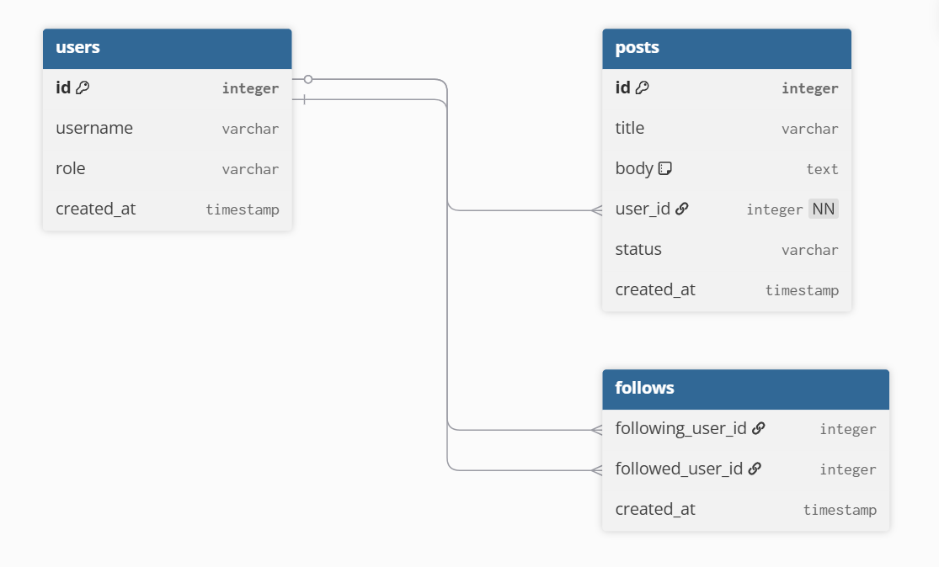
( example taken form dbdiagram.io )

6. API Resource Endpoints
Endpoint | Method | Description
/api/login | POST | Authenticate user and generate session
/api/activities | GET | Fetch logged activities for a user
/api/activity/add | POST | Add new activity entry
/api/summary | GET | Return daily/weekly analytics summary
YAML API Definition File:
Included separately in the submission ZIP as api.yaml.

7. Architecture and Features (optional)

Architecture Overview:
- app.py – main Flask application entry point
- /models – database models using SQLAlchemy
- /routes – Flask Blueprints for user and activity routes
- /templates – Jinja2 HTML templates
- /static – CSS, JS, and chart visualization files

Implemented Features:
User registration and login
Daily activity tracking and habit logging
Visualization dashboard using Chart.js
Summary analytics with date filtering
Responsive UI built with Bootstrap
Secure password hashing and user session handling
Additional Features:
- Export user logs as CSV
- AI-generated weekly summary insights (optional extension)

8. Video Presentation
Drive Link:
https://drive.google.com/file/d/your-video-link-here
(Accessible to all with “View” permission.)

After Creating the doc
Convert this doc to pdf and download ( This should not be included in project report.):
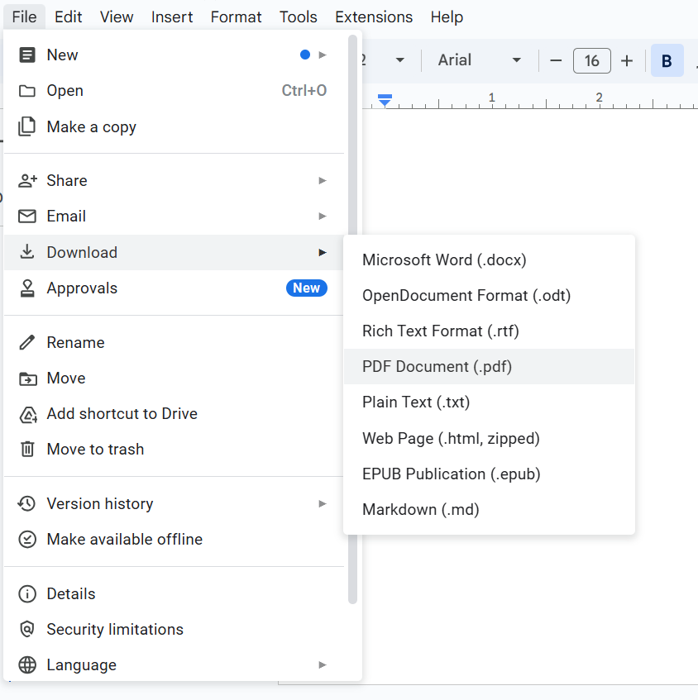

Where should you be adding the report ?
- The report should be included in the zip file which you are submitting.

- Put the report in the drive link and paste the drive link in the viva portal while submitting the app.

Both the things are covered in the video. Please watch it once. How to Submit App Dev 1 & 2 Projects | Full Submission Guide + Viva Workflow | IITM BS

